|  |  |
| --- | --- |
| Semester | T.E. Semester VI – Computer Engineering |
| Subject | Distributed Systems |
| Subject Professor In- charge | Prof. Amit K. Nerurkar |
| Assisting Teachers | Prof. Amit K. Nerurkar |
| Laboratory | Lab number 411 A |

|  |  |
| --- | --- |
| Student Name | Omkar Thube |
| Roll Number | 22102B0005 |
| TE Division | B |

**Title:** Identify the IRCTC system with distributed servers using different DOS/NOS and middleware to facilitate communication and coordination between central and regional servers.

# Explanation:

**DOS** : A Distributed Operating System refers to a model in which applications run on multiple interconnected computers, offering enhanced communication and integration capabilities compared to a network operating system.

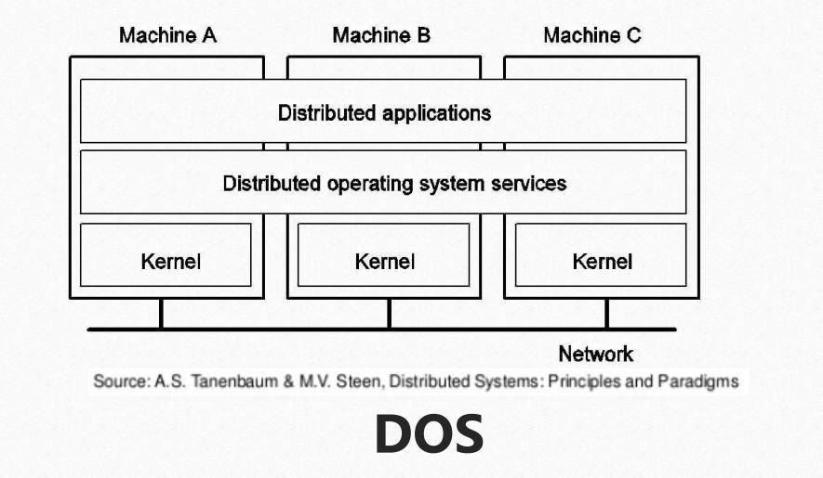

**NOS** : A network operating system(NOS) is software that connects multiple devices and computers on the network and allows them to share resources on the network.

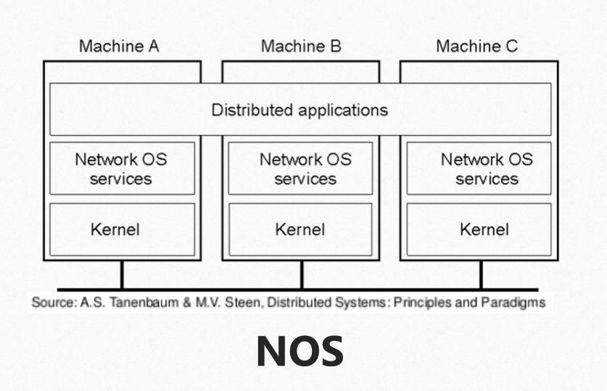

**Middleware** : Middleware in Distributed Systems is a layer of software that acts as an intermediary between different software applications or components within a distributed system, facilitating communication, data management, and service integration.

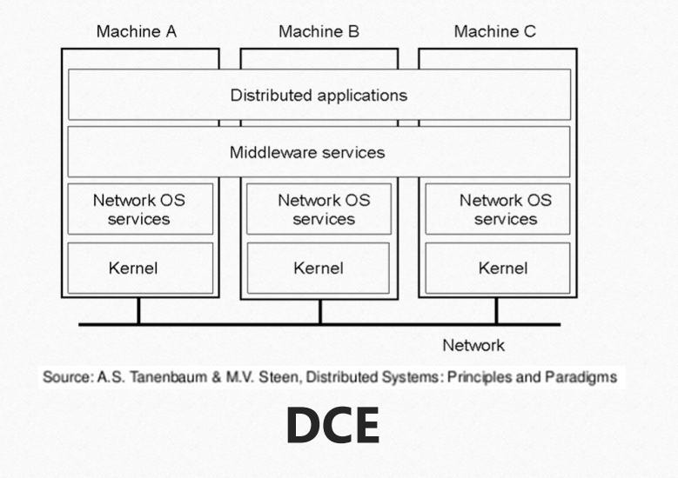

# Difference between DOS , NOS and Middleware

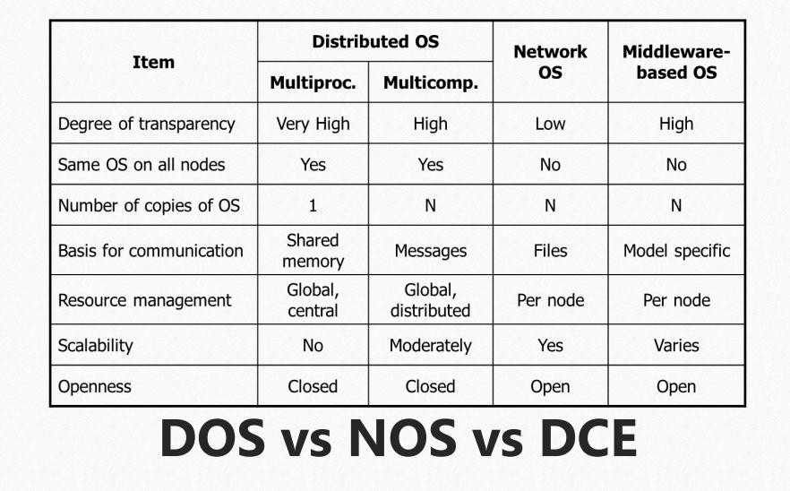

**Names in Distributed Operating System –**

1. Amoeba
2. Mach
3. Inferno
4. V System
5. Sprite

# Names in Network Operating Systems –

1. Microsoft Windows Server
2. Linux (Network Distributions)
3. Novell NetWare
4. UNIX
5. MacOS Server

# Names in Middleware Operating Systems –

1. UNIX/Linux-Based Operating Systems
2. Windows Server Operating Systems
3. Real-Time Operating Systems (RTOS)

# End Result:

Distributed Operating System (DOS)

* + Purpose: Manages distributed computing systems where tasks are distributed across multiple servers.
  + IRCTC Implementation:
    - Clustered Linux Servers: IRCTC likely uses a distributed architecture based on Linux to handle ticketing, payments, and other services.
    - Load Balancers: Systems like HAProxy or AWS Elastic Load Balancing are used to distribute user requests across multiple servers.

Network Operating System (NOS)

* + Purpose: Facilitates the operation and communication between servers in a network.
  + IRCTC Implementation:
    - Cisco IOS or Juniper JunOS: Networking equipment like routers and switches might use these NOS to manage data traffic.
    - Distributed Databases: Oracle RAC (Real Application Clusters) or similar technologies enable high availability and data distribution.

Middleware

* + Purpose: Acts as a bridge between applications and operating systems, ensuring smooth communication and transaction processing.
  + IRCTC Middleware Technologies:
    - Application Servers: Middleware like JBoss, WebLogic, or Apache Tomcat to manage and deploy Java-based web applications.
    - Messaging Queues: Tools like RabbitMQ or Apache Kafka might be used for asynchronous communication between services.
    - APIs and Web Services: REST or SOAP-based APIs enable external systems like banks and payment gateways to interact with IRCTC.

User Booking Request:

* + Middleware like Apache Kafka ensures the request is queued and forwarded to the application server (e.g., JBoss or WebLogic).

Database Query:

* + Middleware like Oracle RAC ensures high-performance access to ticket inventory databases. Payment Gateway:
  + Integration middleware like MuleSoft or TIBCO securely connects to payment gateways (e.g., PayU, Razorpay).

Response:

* + Web middleware like Nginx or Apache HTTP Server delivers the response to the user.

# Conclusion:

We choose this solution because it ensures efficient processing, high scalability, and secure transactions. Apache Kafka handles user requests efficiently, Oracle RAC provides fast database access, MuleSoft/TIBCO enables secure payment gateway integration, and Nginx/Apache HTTP Server ensures quick response delivery. This combination guarantees the system can handle high traffic, maintain reliability during peak periods, and securely process bookings and payments, making it ideal for IRCTC's needs.